EXPERIMENT 5

AIM: To open the HTML file using localhost

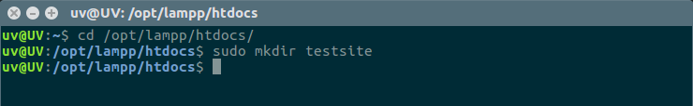
- Make a folder named “testsite” in /opt/lampp/htdocs of Xampp Application.

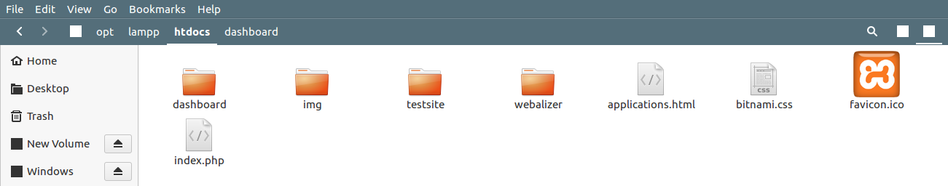

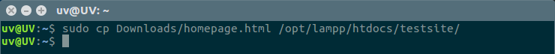
- Copy the html file in the testsite folder.

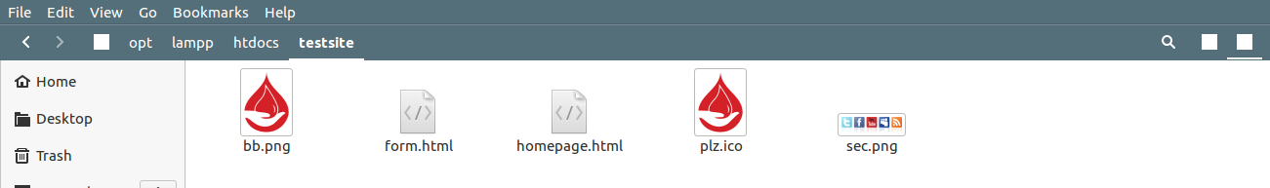

- Open the browser and write localhost/testsite/homepage.html
